**Noise** **pollution** **objectives**:

The objective of addressing noise pollution is to monitor and mitigate excessive noise levels in urban and industrial areas. This is essential for maintaining the well-being of residents, as prolonged exposure to high noise levels can lead to health issues. The goals include real-time noise monitoring, data analysis, and providing information to the public for better decision-making.

**Iot sensor deployment:**

1. **Sensor selection**:

appropriate noise sensors (e.g., microphones or sound level meters) that can capture sound data accurately.

**2.SensorPlacementDeploy** :

these sensors strategically in various locations across the target area, considering factors like population density, traffic patterns, and industrial zones.

**3.Connectivity**:

Ensure these sensors are connected to a central hub using wireless technologies like Wi-Fi, LoRa, or cellular networks.

**4.DataTransmission**:

Establish a reliable data transmission protocol to send sensor data to a central platform for analysis.

**Platform** **devlopment:**

**1.Data Ingestion**:

Create a data ingestion system to receive and store data from the IoT sensors.

**2.Real-time Processing**:

Develop algorithms for real-time noise data processing, such as noise level calculations and anomaly detection.

**3.Data Storage**:

Set up a robust database system to store historical noise data for trend analysis.

**4.User Management**:

Implement user authentication and authorization for access control.

**5.Visualization**:

Create interactive dashboards for users to monitor noise levels in real-time.

**Mobile** **app development**:

**1.User Interface Design**:

Design an intuitive mobile app interface for users to access noise data easily.

**2.User Registration**:

Allow users to register and create profiles.

**3.Real-time DataDisplay**:

Integrate with the platform to fetch and display real-time noise data on the mobile app.

**4.Historical DataAccess**:

Provide access to historical noise data for trend analysis.

**5.Alertsand Notifications**:

Implement alerting mechanisms to notify users when noise levels exceed predefined thresholds.

**6.Geolocation**:

Utilize GPS for location-specific noise data and maps.

**Python Code for Implementation**:

Here's a simplified example of Python code for receiving and processing data from IoT noise sensors using a hypothetical library called "iotnoise" and a platform API:

```python

import iotnoise

import platform_api

# Initialize IoT noise sensors

sensors = iotnoise.initialize_sensors()

# Create a connection to the data platform

platform_connection = platform_api.connect()

# Continuously collect and send data to the platform

while True:

noise_data = iotnoise.read_data()

platform_api.send_data(platform_connection, noise_data)

# Close connections and perform data analysis as needed.

```

**Sensor iot diagram:**

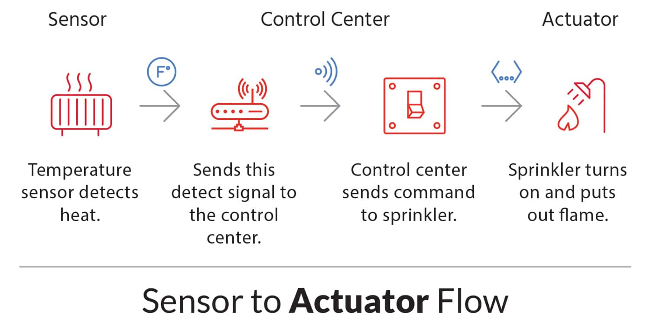

**Noise pollution platform:**

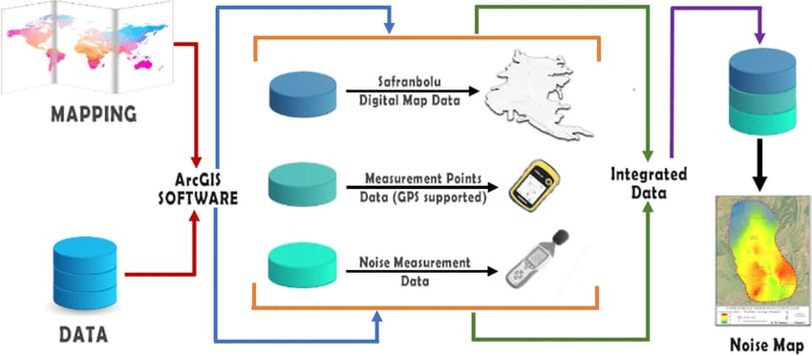

**Noise pollution Interfaces :**

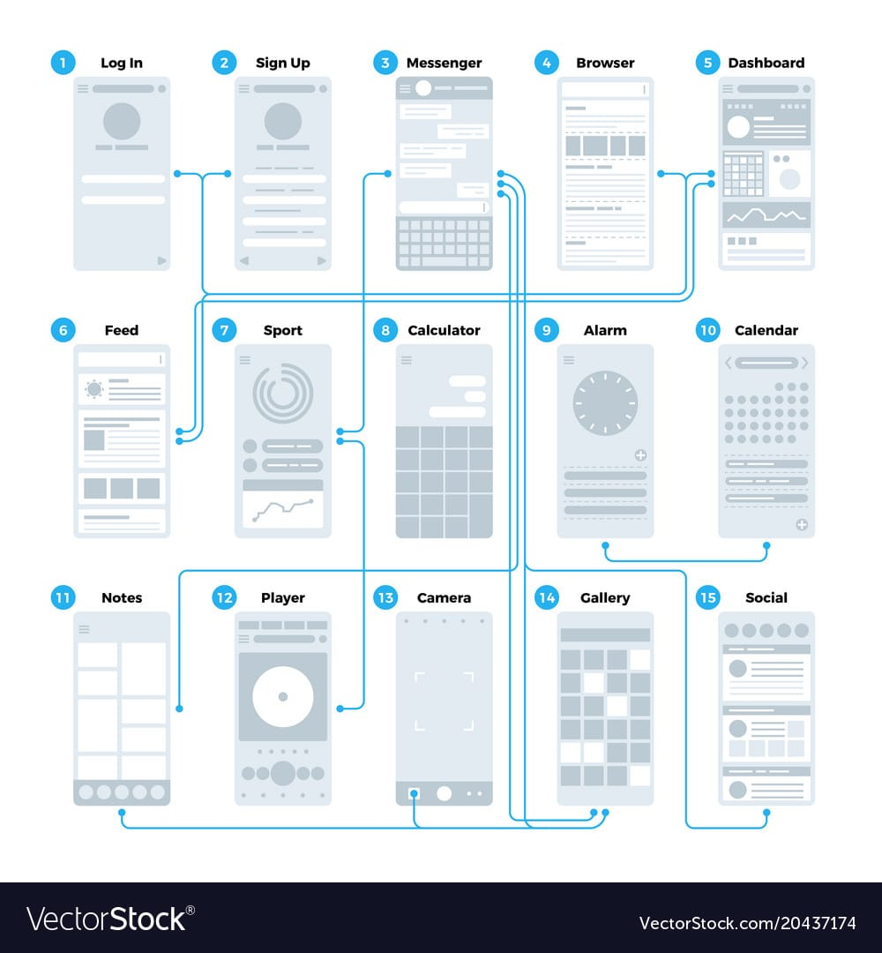

**,real-time noise level monitoring systems significant role in promoting public awareness and contributing to noise pollution mitigation. these systems offer several benefits:**

**1. awareness:**

people become more aware of the noise levels in their surroundings when they have access to real-time data. This can lead to a better understanding of the impact of noise pollution on their health and well-being.

**2. Compliance**:

Real-time monitoring can help enforce noise regulations and zoning ordinances, ensuring that businesses and individuals adhere to permissible noise levels.

**3.Behavioral Changes**:

When individuals and businesses are aware of their noise impact, they are more likely to make conscious efforts to reduce noise, such as using quieter equipment or adjusting their activities.

**4.Data for Policymaking**:

Governments and local authorities can use the data collected to make informed decisions about noise pollution policies and regulations.

**5.Targeted Interventions**:

Real-time monitoring allows for a quicker response to noise complaints, enabling authorities to take action when noise levels exceed acceptable limits.

**6.Research and Analysis**:

Researchers can use the data to study noise patterns, identify sources of noise pollution, and develop more effective mitigation strategies.

Overall, real-time noise level monitoring systems can empower both individuals and authorities to take proactive measures in addressing noise pollution, ultimately leading to a quieter and healthier environment.